**Instructions:**Replace **[bracketed red text]** with the requested information or screen capture.  
Replace **bracketed red text with black text**.  
Use a snippet tool to capture parts of the screen and insert those images into the template.  
**Do not remove tags from this template. An example of a tag is [C.1]. All fields are required.***Please do not alter template formatting or delete parts of this template.*

Part A - Student Information: **[A].   
1. Student Name: [STUDENT NAME – Aamir, Patel]  
2. Student Email: [Email: - Aamir8567@gmail.com]  
3. Student Cell: [Cellphone: - (872) 985 - 4361] Optional**

Go back to the instructions and continue with Part B.

Part B – Drupal CMS Website and Web Host Information:

**Drupal 9 site on a Shared web host or Local Host Dev CMS builder**

1. Enter the following shared web host Drupal site information **[B.1]**
   1. Shared Web Host Company Name: [ NameCheap ]
   2. Shared Web Host URL: [ Namecheap.com ]
   3. Shared Web Host account username: [ aamir8567 ]
   4. Shared Web Host password: [ Kamboli90123! ]
   5. Website Admin Username: [ aapadcpate ]
   6. Website Admin Password: [ 9aIwR@LZB%#uk9Fgh3 ]
   7. Database Name: [ drup838 ]
   8. Table Prefix: [ drpp_ ]
   9. Website URL: [ <https://aamirpatel.tech/tutorial08/> ]

**Drupal 8 or 9 site on Pantheon (PaaS)**

1. Enter the following shared web host Drupal site information **[B.2]**
   1. PaaS Drupal version: [Drupal 9 – major.minor.patch]
   2. PaaS Drupal 9 Front end site URL: [ website URL here ]
   3. PaaS Drupal 9 site Admin Username: [ website admin username here ]
   4. PaaS Drupal 9 site Admin Password: [ website admin password here ]

Go back to the instructions and continue with Part C.

Part C – Extending Drupal 8-9 with Core Modules  
  
Baseline Drupal 8-9 sites have Bartik as the default client facing theme.   
Please make sure that Bartik is the default client facing theme before starting this part.   
  
Drupal 8-9 Screen Captures:

1. SCREEN CAPTURE – Backend Admin toolbar > Extend with CORE Contact module visible. [C.1][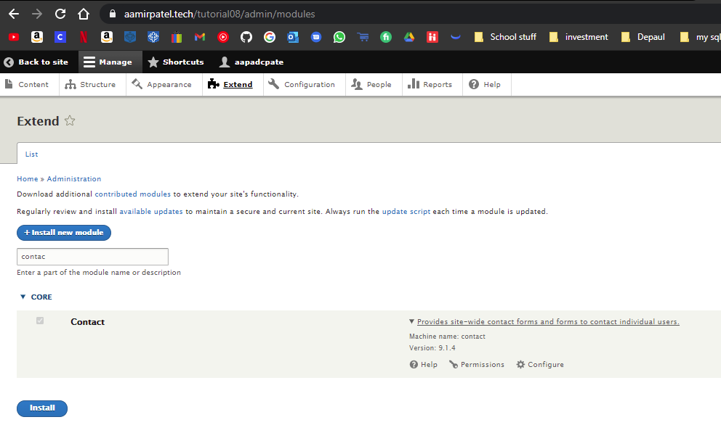]
2. SCREEN CAPTURE – Backend Admin toolbar > People > Permissions – with the Contact module permissions visible.   
   [C.2][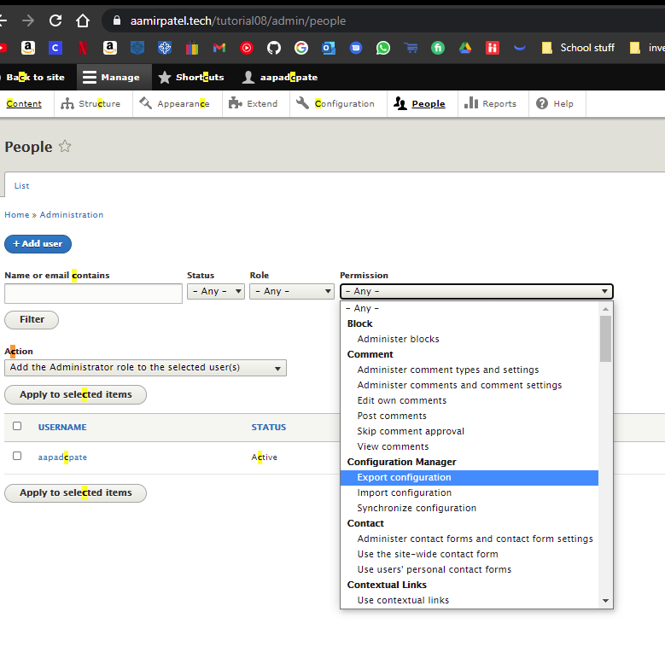]
3. SCREEN CAPTURE – Front-end - While on a web browser where you are not logged, select Main Navigation Contact Us link and display the Contact Us form, then take a screen capture of it where the Drupal website Main menu navigation and the web browser address bar are visible and readable.  
   [C.3][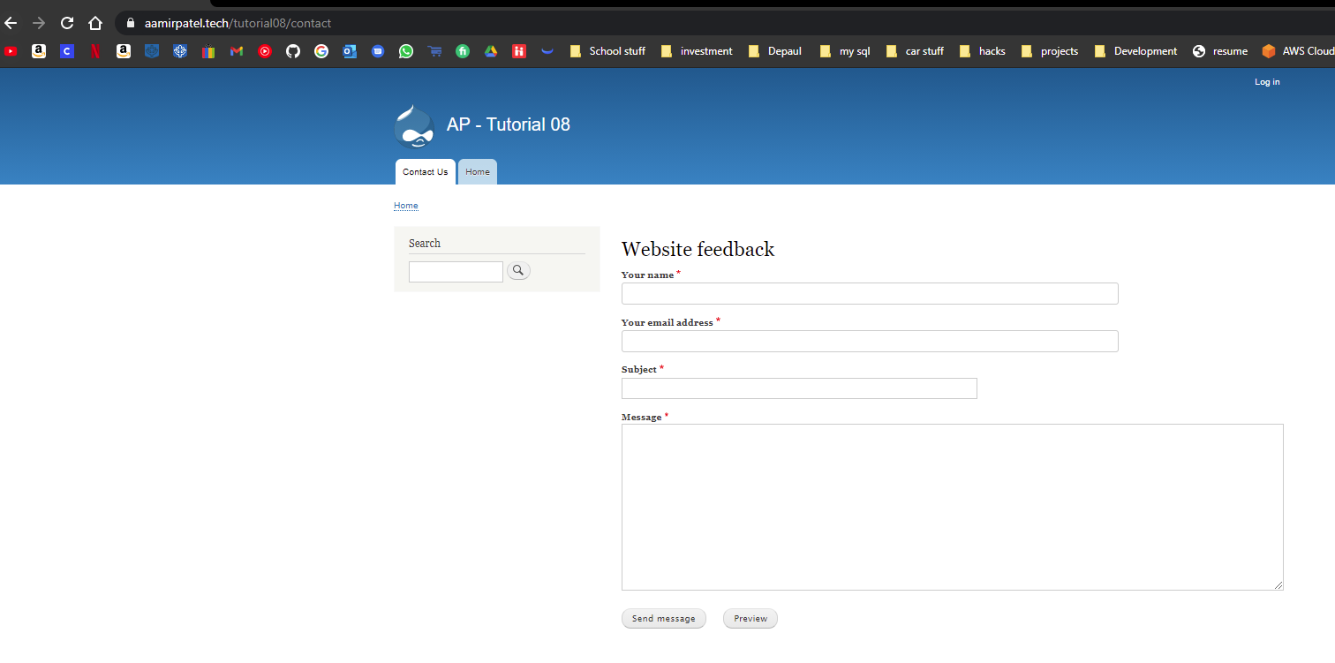]

Part D – Creating new Drupal Content Types   
For your screen captures, form the Platform you used for this section on contrib. modules

1. SCREEN CAPTURE – Backend Admin toolbar > Structure > Content Types  
   [D.1][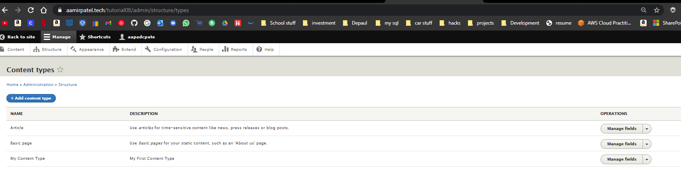]
2. SCREEN CAPTURE – Backend Admin toolbar > Structure > Content Types, select Edit for the “My content type” – record Screen captures of all the TABS  
   [D.2.1][Edit TAB - 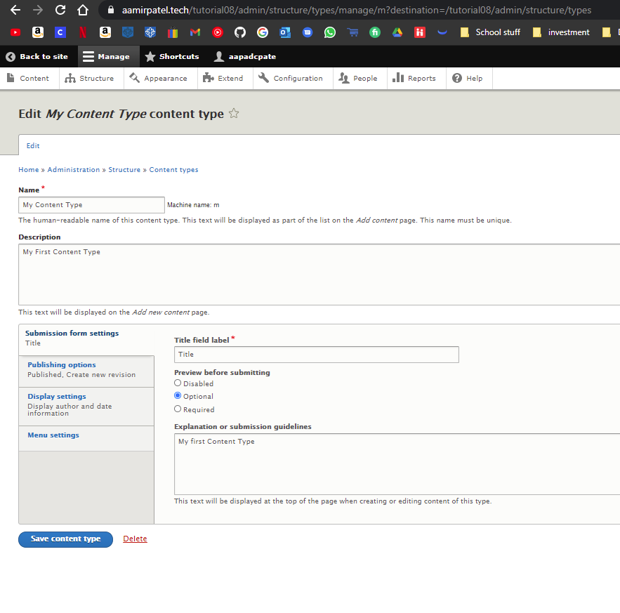]

[D.2.2][Manage fields - 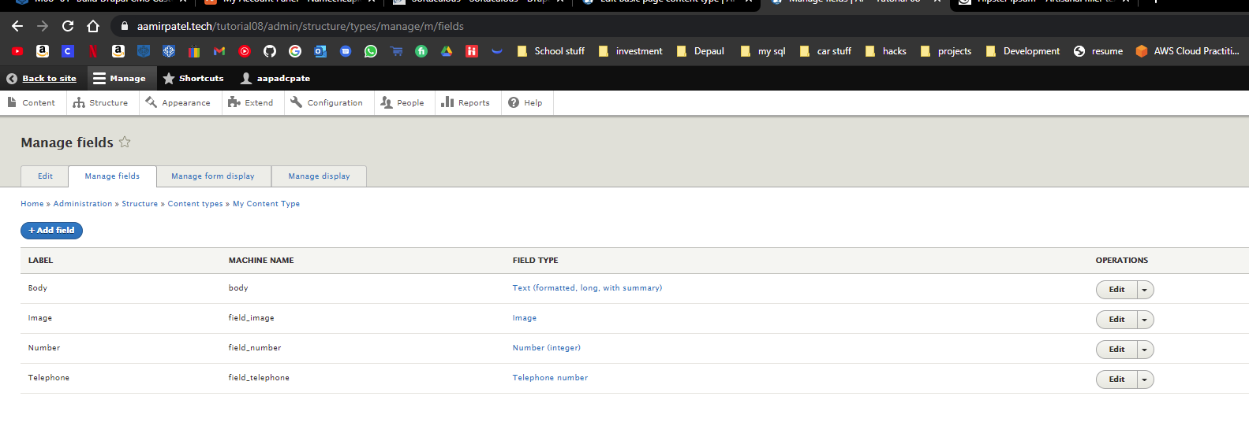]

D.2.3][Manage form Display - 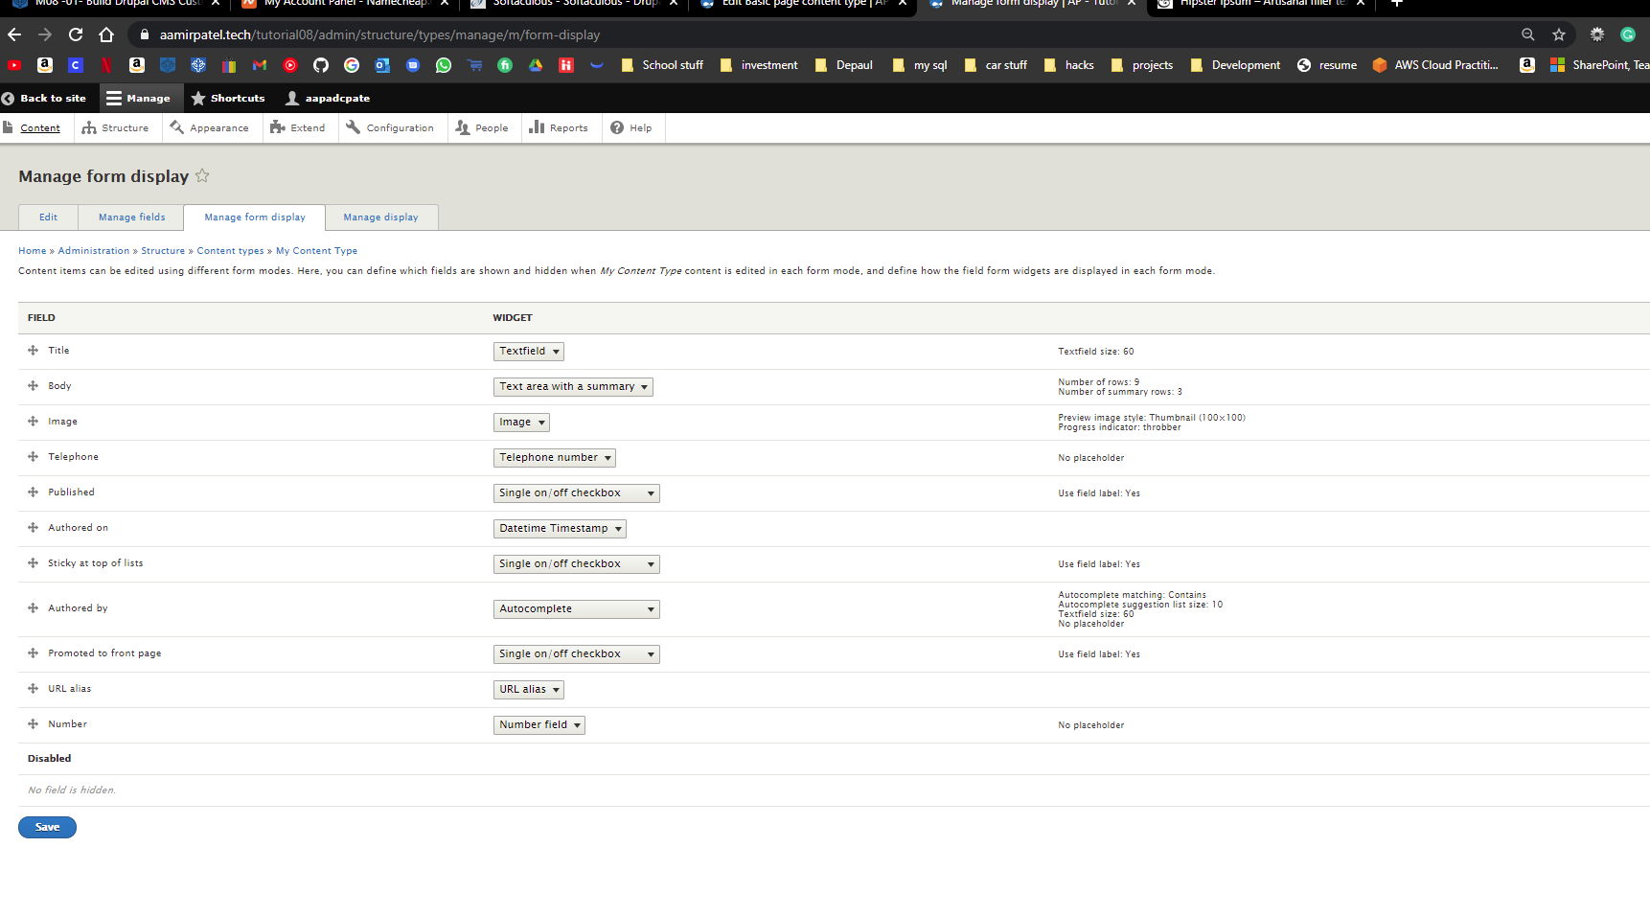]

D.2.4][Manage Display - 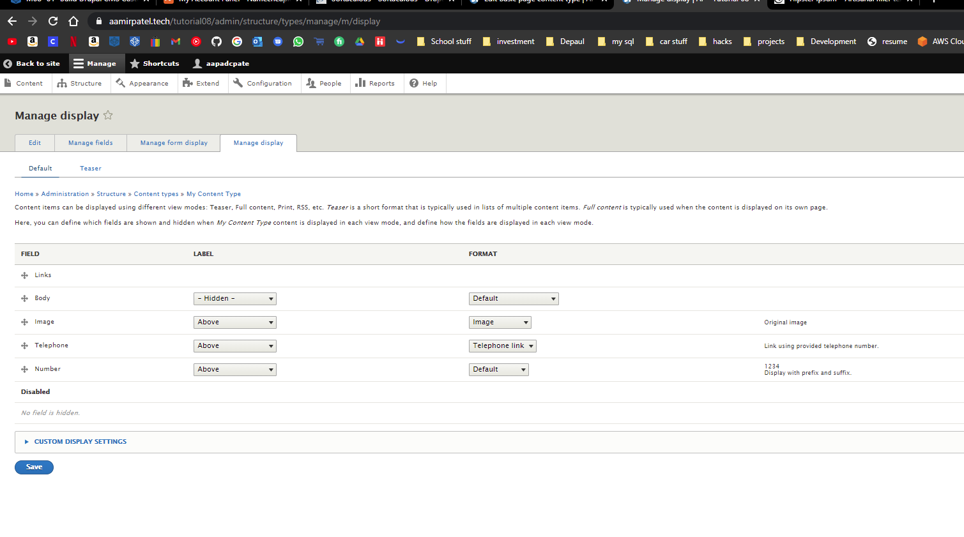]

Part E – Extend Drupal 8-9 with Contributed Modules   
For your screen captures, form the Platform you used for this section on contrib. modules.

1. SCREEN CAPTURE – Backend Admin toolbar > Extend – with ADMINISTRATION package visible  
   [E.1][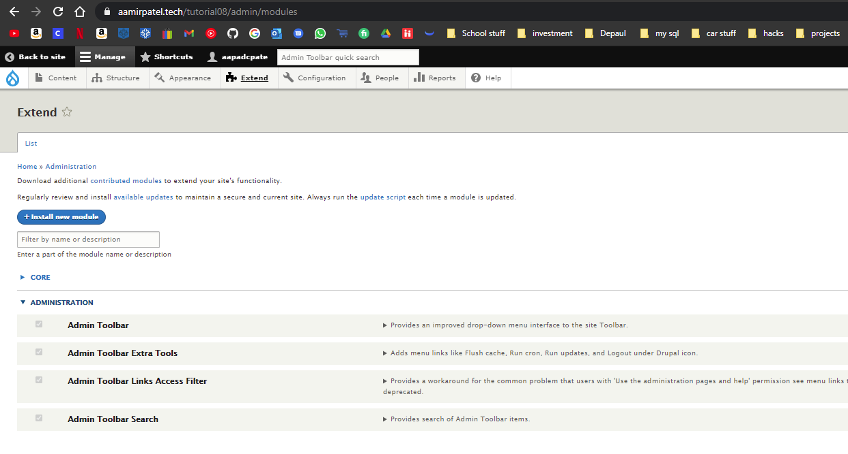]
2. SCREEN CAPTURE – Backend Admin toolbar > Extend – with the OTHER package visible  
   [E.2]  
   [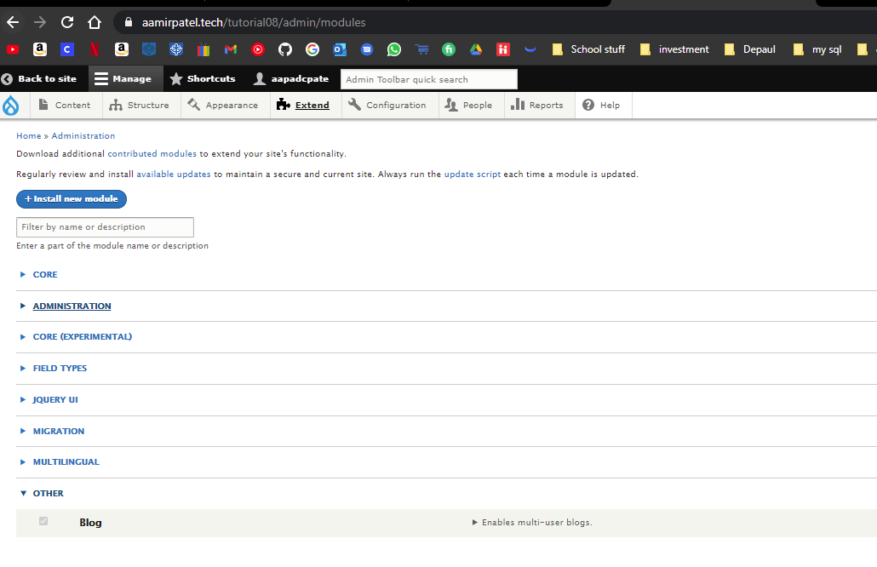]
3. SCREEN CAPTURE – Backend Admin toolbar > Extend – with the FIELD TYPES package and the Simple Google Maps module visible  
   [E.3]  
   [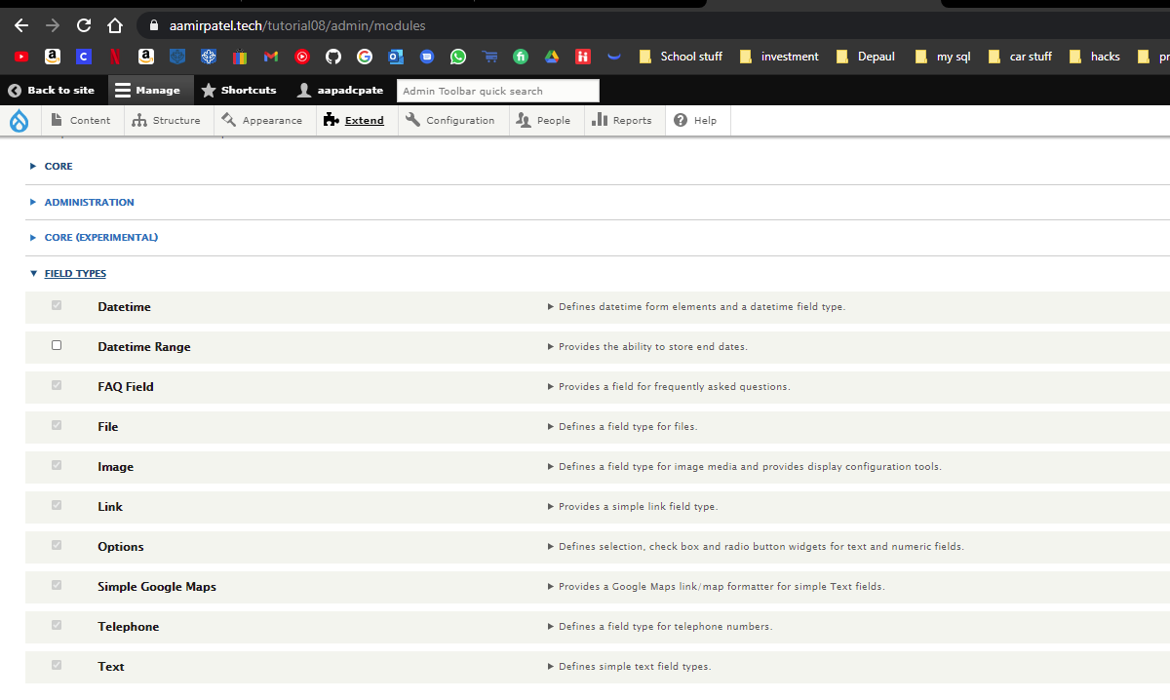]
4. SCREEN CAPTURE – Backend Admin toolbar demonstrating that the Admin Toolbar extension works.   
   [E.4]  
   [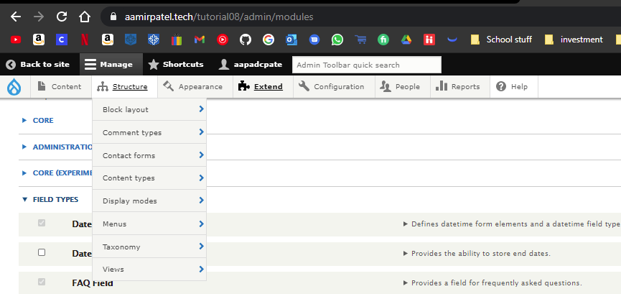]
5. SCREEN CAPTURE – Front End (on a different web browser where you not logged in as the site admin) Home (front) page showing a blog with at least 2 blog entries. Please make sure the screen capture has the web browser address bar visible.   
   [E.5]  
   [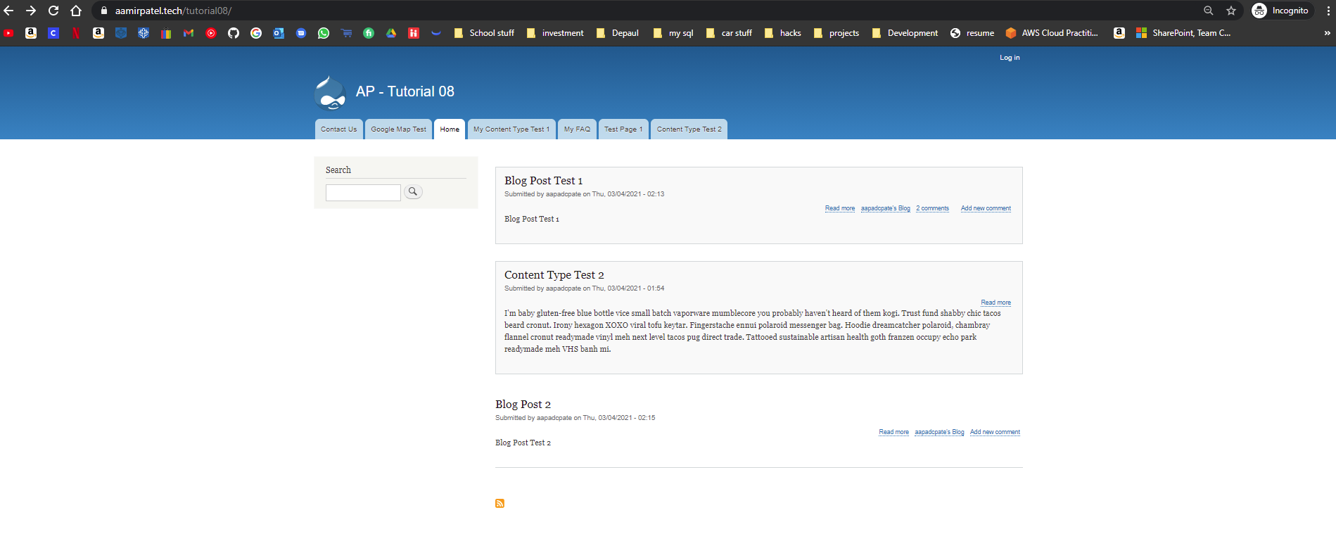]
6. SCREEN CAPTURE – Front End (on a different web browser where you not logged in as the site admin) showing the Google Map page selected and visible. Please make sure the screen capture has the web browser address bar is visible.   
   [E.6]  
   [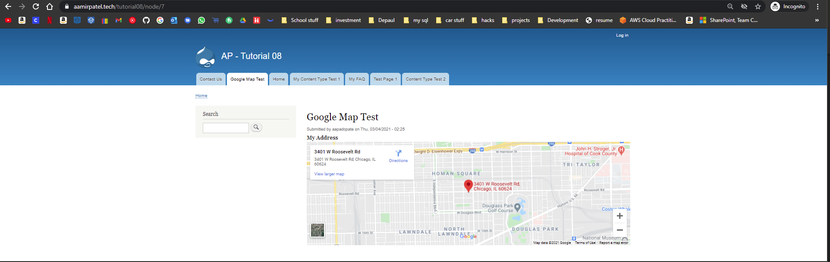]

Go back to the instructions and continue with Part F.

Part F – Introducing Module Dependencies

1. SCREEN CAPTURE – Backend Admin toolbar > Extend – with the FIELD TYPES package and FAQ Field module selected (checked) visible  
   [F.1][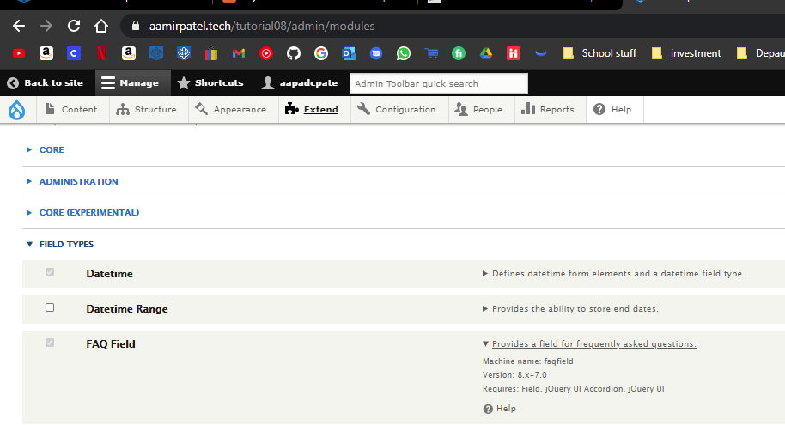]
2. SCREEN CAPTURE – Front End (on a different web browser where you not logged in as the site admin) showing the FAQ page with at least two FAQ questions and answers visible. Please make sure the screen capture has the web browser address bar is visible.   
   [F.2]  
   [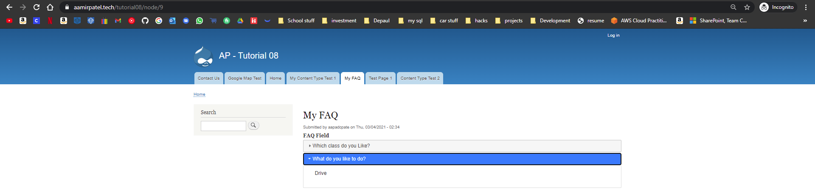]

Part G – Extend Drupal with Custom Modules – Codeanywhere

G.1 Build a Drupal 9 site on Codeanywhere

1. Enter the following Codeanywhere web host Drupal 9 site information **[**G.1**]**
   1. Codeanywhere account username(email): [ aapadcpate ]
   2. Codeanywhere account password: [9aIwR@LZB%#uk9Fgh3]
   3. Drupal version built (major.minor.patch): [ 9.1.4 ]
   4. Site Title: [ ap-tutorial-08 ]
   5. Website Username: [ mpate180@depaul.edu ]
   6. Website Password: [ Kamboli1! ]
2. SCREEN CAPTURE of the website backend with the “/hello/world” appended to the base site URL with the web browser address bar visible. [G.2]   
   [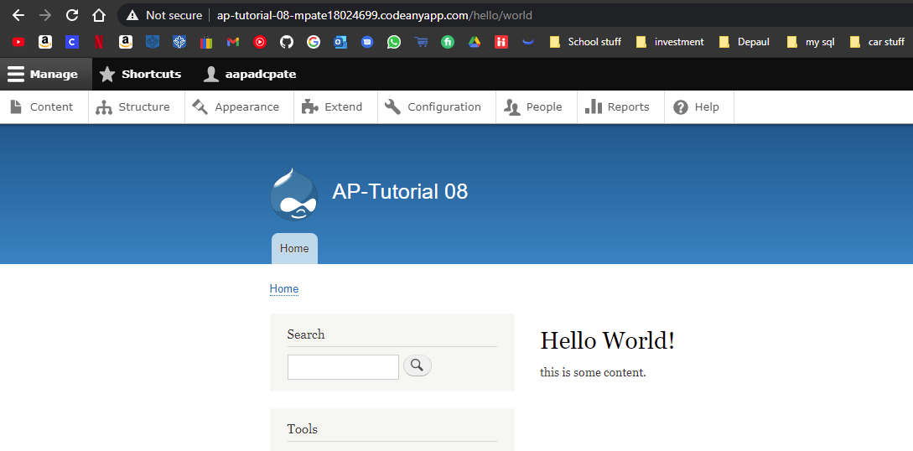]
3. Take a screen capture of the hello_world custom module folder fully expanded. [G.3]   
   [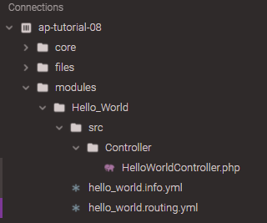]
4. SCREEN CAPTURE of the backend with the “/my/heart” appended to the base site URL with the web browser address bar visible. [G.4]   
   [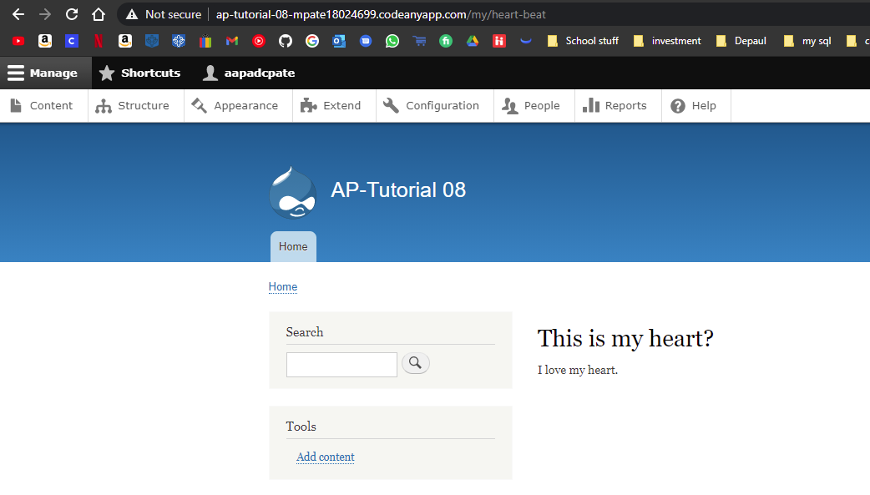]
5. Codeanywhere IDE File Explorer – take a screen capture of the my_heart custom module folder fully expanded. [G05]   
   [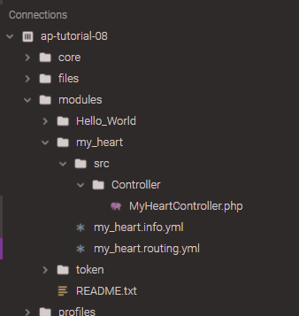]

Go back to the instructions and continue with Part H.

Part H – Deleting Drupal 8-9 Modules

**Please do not uninstall or remove (delete) any Drupal CORE modules.**

Please review the presentation “M08 - 02 - Installing and Removing Drupal Modules” and watch the Part H videos before answering these questions.

1. How many different ways are there to install a Drupal contrib module from the Drupal admin back-end?  
   [H.1]  
   [There are two possible ways to install new contrib, through link or as a File.]
2. Write down the steps to install a Drupal Contrib module using “Install from a URL” on the Extend page?  
   [H.2]  
   [ To install Drupal Contrib through URL, you first need to get the URL for the contrib from Drupal webpage.

Then you should confirm that it matches all of the requirements of your drupal page, Then you can follow these steps.

Admin Panel > Extend > Install New Module > Paste your retrieved URL in the text box (Install from a URL) > Click Install > Press Enable Newly Added Modules > Search Contrib > Select arrow on left > press install at the bottom. ]

1. Write down the steps to install a Drupal Contrib module using “Upload a module or theme archive to install” on the Extend page?  
   [H.3]  
   [To install Contrib through archive, you first need to get the archive for the contrib from Drupal webpage.

Then you should confirm that it matches all of the requirements of your drupal page, Then you can follow these steps.

Admin Panel > Extend > Install New Module > Press (Choose File) > Select the .tar or .zip file > Click Install > Press Enable Newly Added Modules > Search Contrib > Select arrow on left > press install at the bottom.]

1. Write down the steps to uninstall a contrib module that is installed and enabled.  
   [H.4]  
   [ To Uninstall a contrib module, you can follow these steps: -

Admin Tool Bar > Extend > Uninstall > Select plugin that you want it to uninstall > Press Uninstall. ]

1. Write down the steps to delete (remove) an already uninstalled Drupal contrib module.  
   [H.5]  
   [To remove a contrib that is already uninstalled, you can go to the file system for the webpage.

File System > modules > Zip the folder with the plugin name (For backup) > Delete the original folder. ]

1. Can you delete (remove) a Drupal 8-9 module from your Drupal site’s file system if it is installed and not enabled on your Drupal site, and if not why not? [H.6]  
   [Yes you can uninstall the module, because it is not being used, drupal does not care since it will not affect the current webpage in anyway.]
2. Can you remove (delete) a Drupal 8-9 module from your Drupal site’s file system if it is installed and enabled on your Drupal site, and if not why not? [H.7]  
   [No, Drupal will not allow you to delete the module, if it is enabled. So you will have to uninstall then delete the folder.]
3. Will Drupal allow you to remove (delete) a Drupal 8-9 module from your Drupal site if it is installed, enabled, and has been used to create content nodes, and if not why not?  
   [H.8]  
   [Yes Drupal will let you uninstall modules, but before you confirm your uninstall, it will tell you which nodes will be affected, so you can confirm the changes that will be made.]
4. Do Drupal module uninstalls always work? Please write a few sentences about a failed Drupal module uninstall that we covered in this part and write about the problems it caused with the Drupal site?  
   [H.9]  
   [No, they do not always work. Sometimes modules have dependencies, and you will not be able to uninstall modules before deleting its dependencies.]
5. What is the difference between uninstalling a Drupal module and removing (deleting) a Drupal module from the file system?  
   [H.10]  
   [Uninstalling a module means removing from the webpage, (there is a reversal). But Remove a module means removing the module from the file system/brains of the webpage (there is no reversal).]

Please go back to the instructions and work on the next part.